Yin and Yang Balancing Yoga
This technique is designed to balance your yin and yang energy as well as your meridian system and chakras to help your Chi/Bio energy flow.

There is also a meditation which you can choose to do when you have extra time.

Yin and Yang Yoga takes only 3 minutes to do and has to be done one during the day time, another during the night time. So it takes 6 minutes in total per day.

Please remember that our physical health and emotional balance are our own responsibilities.

This yoga and meditation technique is registered in the name of our Kaia Energy technique group based in Turkey.

Heera Burcu Cedetas

Yin & Yang Yoga
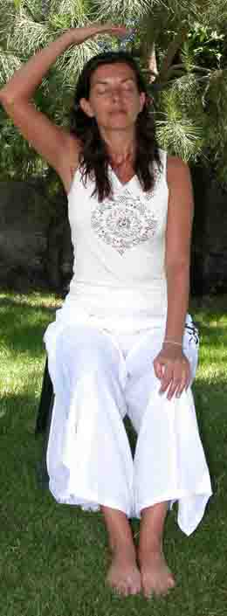  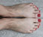 |  |  |  | 1. Step:  - Sit on a chair or stool.  - Your feet should be touching each other as shown at the small picture.  - You should place yourself at the edge of the chair/stool.  - Pay attention to keep your back straight and keep your feet clinked to each other.  - Start with intending your female and male energies to reach a healthy balance.  - Put your left hand on your left knee and keep your right hand 10 cm above of your “crown” chakra.  - Try to feel the energy in your crown chakra while moving your hand slowly clockwise.  - Crown chakra is an area dominated by female energy. You are expected to feel chilliness in your hand.  - You are being affirmed to your female energy with your right hand which is male energy.  - Feeling extreme heat or coldness shows unbalance.
2. Step:  - In the second step, right hand will be on right knee, left hand will be under root chakra.  - Try to feel your male energy by moving your left hand slowly in clockwise direction.  - You are expected to feel warmth in your hands.  - The heat’s being little or too much shows unbalance. |  |  |  |  |  |  |  |  |  |  |  | 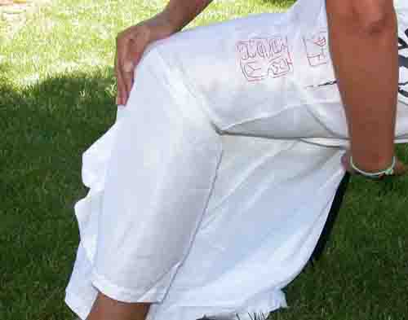

First two steps:
- Makes you understand the situation of your female and male energies.
- You open up your female and male energies consciously for communication.
- You also start conscious communication with universal female and male energies. This way it will be easier to set your balance making use of healthy female and male balances of the universe.
- Do not forget that each little piece is a small reflection of the whole. Accordingly, each chakra has both energies.
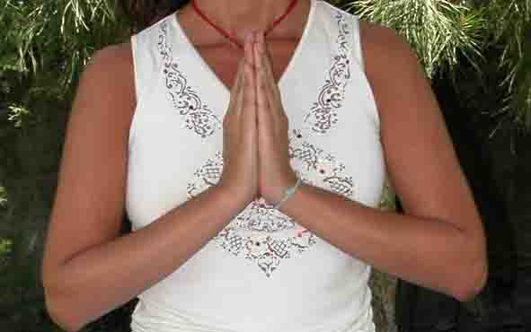 |  |  |  |  |  | 3. Step:  - After brining your hands to praying position keep them in line with your heart chakra for 5-6 seconds.  - The purpose of this position is to move your awareness to your the centre of balance.  - We will be repeating this position in transitions.
4. Step  - Bring hands in praying position above crown chakra.  - I advise you not to change the praying position and to follow the skeleton form while carrying hands above.  - This way the balance duration is facilitated. |  |  |  |  |  |  |  |  |  | 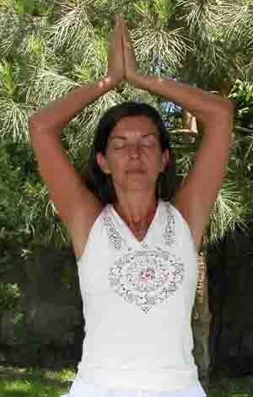
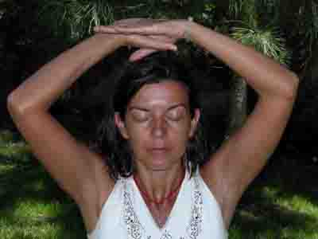 |  |  |  |  | 4. Step Continue  - Open up your hands towards right and left and do the symbol of yin and yang as shown at the small hand picture.  - One palm will look down, the other will look up. Doesn’t matter which one looks which direction. Let your hands decide. Thumbs should be in each other.
- The yin and yang symbol created in the 4th step is like the photo.  - Your hands should decide which hand looks which direction.  - We keep this position for 30 seconds. |  |  |  |  |  |  |  |  |  |  |  |  | 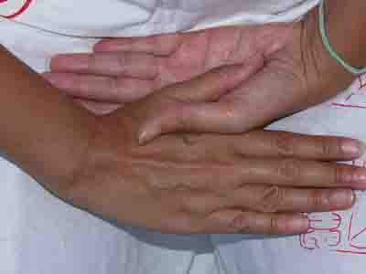
5. Step
- After bringing your hands to praying position, keep them in line with your heart chakra for 5-6 seconds.
6. Step  - Bringing right hand to left shoulder and left hand to right knee, we let the energy flow and balance.  - We keep this position for 15 seconds.  - This and the next position aim to establish the right and left balance of the body. |  |  |  |  |  |  |  |  |  |  |  |  |  |  | 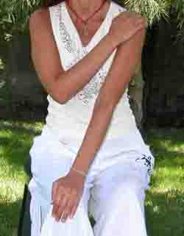
 |  | 7. Step  - This time, left hand is on right shoulder and right hand is on left knee.  - Again we will let the energy flow and balance for 15 seconds.  - If you want to stay more than 15 seconds, remember that you have to stay equal seconds in 6th and 7th steps.
8. Step
- After bringing your hands to praying position, keep them in line with your heart chakra for 5-6 seconds.
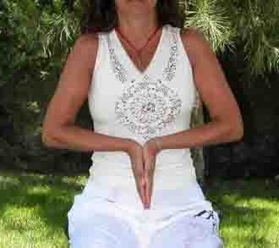 |  |  |  |  | 9. Step  - Turn your hands in the praying position so that the finger points face downwards.  - Move your hands in line of the root chakra while they are in praying position and facing downwards.
10. Step
- Change your hand to yin and yang position from the praying position and keep it in line with your root chakra.
- You did this transition in your crown chakra as well. The same principles will be valid.
- Stay 30 seconds for energy flow and balance.
- If you want to stay more than 30 seconds, I’d like to remind you that it would be better if you can stay the same length of time in the 4th step according to the balance rule. Durations of 4th and 10th steps will be better if they are equal.
11. Step
- After bringing your hands to praying position, keep them in line with your heart chakra for 5-6 seconds.
12. Step  - Cross your hands at the breast level which is also your heart chakra.  - Left hand will be under right armpit, right hand will be under your left armpit.  - Duration 15 seconds. If you want to stay longer you have to stay the same amount of time in 13th step as well. |  |  |  |  |  |  |  |  |  |  |  |  |  | 
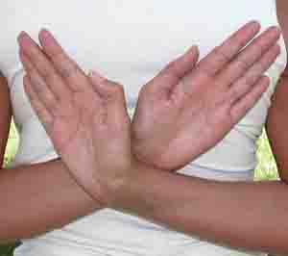 |  |  | 13. Step  - Hands will be crossed on your back at the level of your heart chakra, intersect at the elbows like in the picture.  - This aims to carry the balance of heart chakra to the exit at your back and it is important.  - Duration is 15 seconds or should be equal to the 12th step.
14. Step  - Right hand will be in front of your heart chakra, left hand will be on your back, at your heart chakra.  - Palms will face the chakra.  - Duration is 15 minutes. You can extend the period individually if you like. |  |  |  |  |  |  |  |  |  |  | 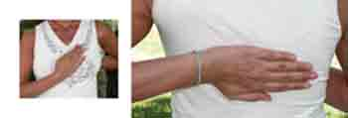
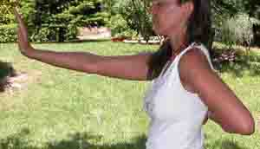 |  |  |  |  | 15. Step  - Bring forward one of your hands.  - Your hand is at 90 degree angle to your arm.  - Your arm is at 90 degree angle to your body.
15. Step Continue  - Immediately bring forward your other arm.  - Each hand is 90 degree angle to the arm and each arm is at 90 degree angle to the body.  - With this position, you’ve started to spread your centre of balance from heart chakra to your aura. |  |  |  |  |  |  |  |  |  |  |  |  |  |  |  |  | 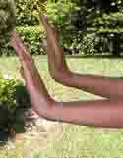
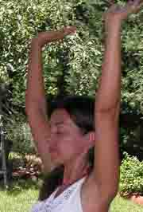 | 16. Step  - Bring both arms, without changing its position to the hands, towards the direction of crown chakra.  - With this position, you continue to spread the balance energy to your aura.  - We are repeating the communication of spiritual and worldly axes that we did at the beginning.
17. Step
- Slide down both hands from your sides.
- Your arms will be in parallel to your body and will be straight in line of your root chakra. Hands are again at 90 degree angle to your arms and will be facing the earth.
- With this position, we complete the repeating the communication of spiritual and worldly axes that we did at the beginning.
- Because of the rule of balance you have to do this yoga twice a day.
- It should be done once with the sun, that is the day, and once with the moon, that is the night.
- Do not forget that if you do it twice during the day, you have to do it twice during the night.
- Yin and yang yoga would support and facilitate healing. It does not do the healing itself. Because of that, do not give up your meditation and Reiki applications.

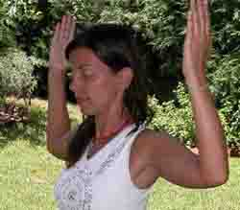 |  |  |  |  |  |  |  | 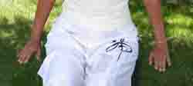

Yin and Yang Balancing Meditation
You can do this balancing meditation after your yin and yang balancing yoga. Yoga is needed to be practise 2 times per day and every day. But meditation is something that you can do occasionally.

You can use this exercise even if you do not know any energy practise.

Since Reiki is very basic Chi energy, there is no harm do it with reiki. But please do not mix this meditation with another practise. It is better to do them separately.

18. Step  - Sit on floor as shown at the picture, with erected spine.  - Your legs have to be parallel to each other and straight.  - Your arms should be at both side of your body, your fingertips should be facing outwards, touching the floor.  - Close your eyes, wish to be connected to the universal energy.  - Wish to have a healthy balance of yin and yang energy and wish to share this healthy balance with the planet.  - Take deep breaths toward you belly. Make sure that your breaths reach your hips.  - Continue until you will start to feel the energy flow at your palms and feet. |  |  | 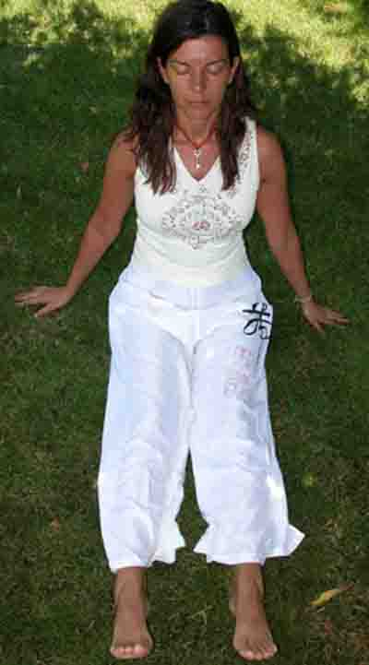
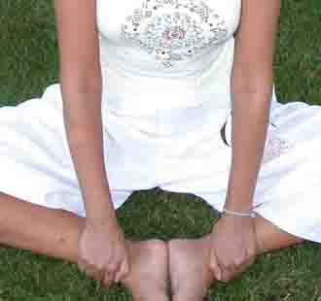 | 19. Step  - Keep your spine erected.  - Your both foot should be facing and touching each other as it shown at the picture.  - Hold your ankles with your hands. Right hand holding right ankle, left hand holding left ankle.  - Holding your ankles will help you sit straight.  - Take a deep breath and give it back as short, equal breaths. If you get use to it, you will be able to breathe out as 14 or 21 equal breath. You should at least do it as 5-6 equal breath.  - Continue to breathe in as deep breath and breathe out as equal short breaths.
- You should be doing this, for at least 45-50 breathe in.
- This breathing will stimulate energy flow at your body, which is why we use short, equal breathing out.

20. Step  - Bend your knees so your legs can have 45 degree angle. Your entire soles should be touching the floor.  - Place your arms backside; your fingertips should be facing outwards, your palms entirely touching the floor.  - Bend your head gently backwards.  - Move your head gently forwards while you are breathing out, and move your head backwards while you are breathing in.  - Repeat this for 3 minutes. |  | 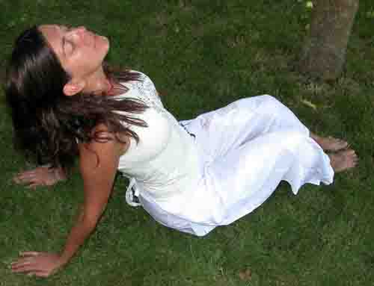
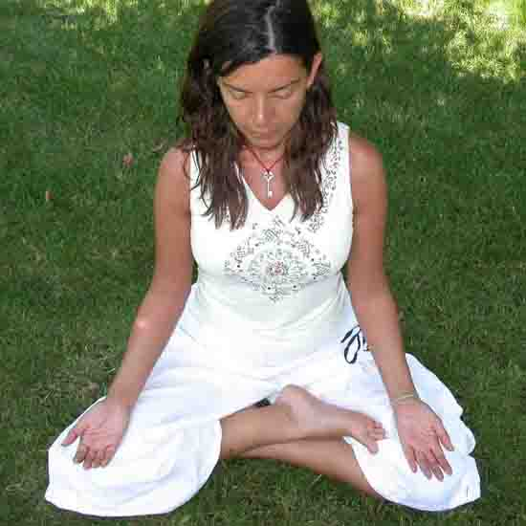 | 21. Step  - Sit down at lotus position if possible. If lotus is too difficult for you just sit down comfortably.  - Your spine should be erected.  - Place your hands at your knees, palms facing upwards.  - Let energy flow trough you, while you sit still at “no mind” state.  - If it is difficult to stay at “no mind” state, concentrate your breathing in and out.  - Your body may start to swing, let it be.  - After a while you may lie down and enjoy the energy flow, your palms should be facing upwards.
- You completed meditation.
- Practise it at nature or at home away from electronic devices.

Heera Burcu Cedetas

